Emerging Terminology

📘 What is Emerging Terminology
# Source: Chatgpt (GPT-4-turbo) at [7/31/2025]
Emerging terminology refers to new or recently developed terms that arise in response to innovations, discoveries, social changes, or technological advances. These terms are often not yet widely standardized or accepted across all users.

🧩 Key Characteristics:
# Source: Chatgpt (GPT-4-turbo) at [7/31/2025]
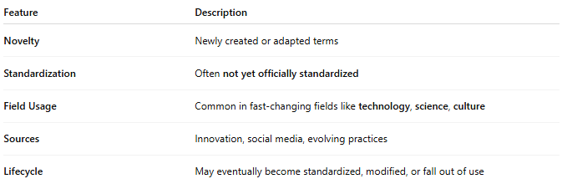
Feature | Description
Novelty | Newly created or adapted terms
Standardization | Often not yet officially standardized
Field Usage | Common in fast-changing fields like technology, science, culture
Sources | Innovation, social media, evolving practices
Lifecycle | May eventually become standardized, modified, or fall out of use

🧠 Who Uses It?
# Source: Chatgpt (GPT-4-turbo) at [7/31/2025]
- Innovators
- Researchers
- Media and tech professionals
- Trend-setters and early adopters
- Younger demographics

💡 Examples:
# Source: Chatgpt (GPT-4-turbo) at [7/31/2025]
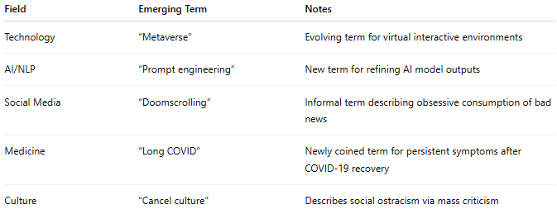
Field | Emerging Term | Notes
Technology | “Metaverse” | Evolving term for virtual interactive environments
AI/NLP | “Prompt engineering” | New term for refining AI model outputs
Social Media | “Doomscrolling” | Informal term describing obsessive consumption of bad news
Medicine | “Long COVID” | Newly coined term for persistent symptoms after COVID-19 recovery
Culture | “Cancel culture” | Describes social ostracism via mass criticism

🆚 Compared to Other Types:
# Source: Chatgpt (GPT-4-turbo) at [7/31/2025]
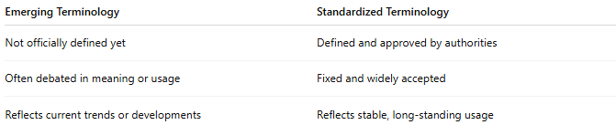
Emerging Terminology | Standardized Terminology
Not officially defined yet | Defined and approved by authorities
Often debated in meaning or usage | Fixed and widely accepted
Reflects current trends or developments | Reflects stable, long-standing usage

